We are ready to get started on your label design!

We just need the following information to get the team started working on your label.

Please take a look at the list below and let me know if you have any questions (feel free to copy and paste the list below in your response if that's easier!)

1. Contact Information to be printed on the label:

Company Name: | Zenyva
Address | P.O. Box 2508, Ramona, CA 92065
Email Address: | info@myzenyva.com
Phone Number:
Social Media: (specify):
Website: | myzenyva.com
Other (QR Code, etc):

2. Product Information:

Product Name: | Zenyva
Key Ingredients (if you’d like to call out anything on the label):
Flavor Name (if applicable):
Bottle Color (white or black): | White
Lid Color (white or black): | White
Lid Type (Ribbed or smooth): | Ribbed
Other information or descriptions to add to the label:

3. Branding and Design Preferences:

Do you have a logo that you would like to apply to your label(s)? (if yes please provide a vector file, or a high resolution image with clear background)
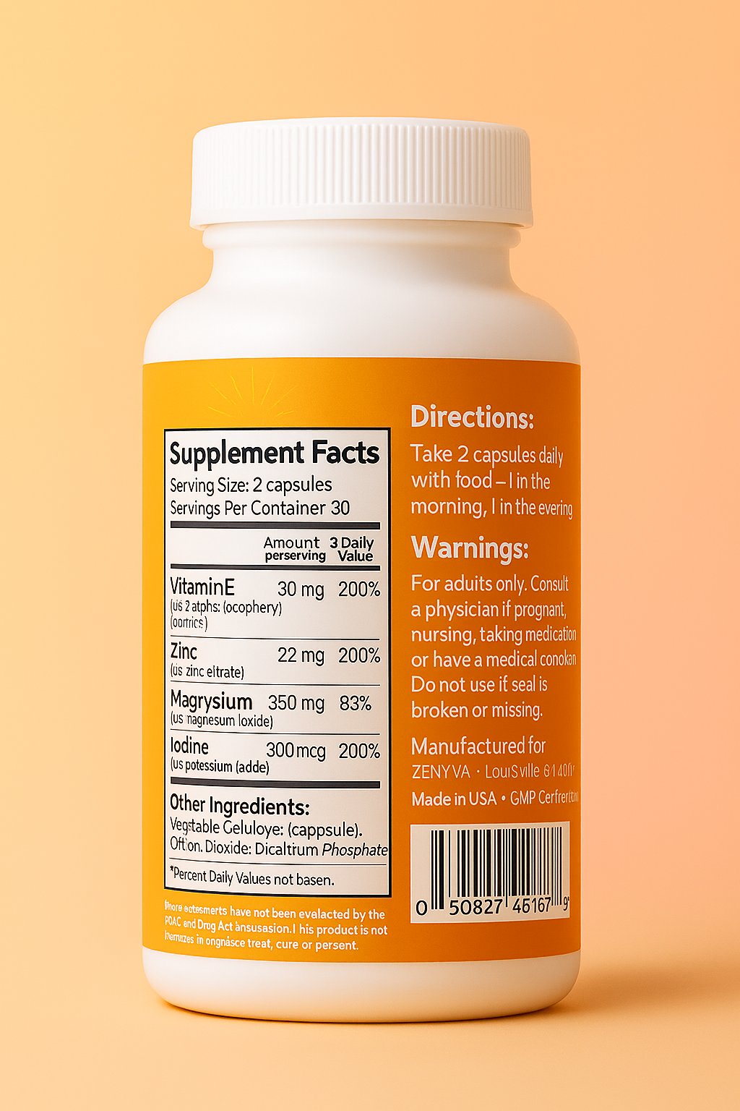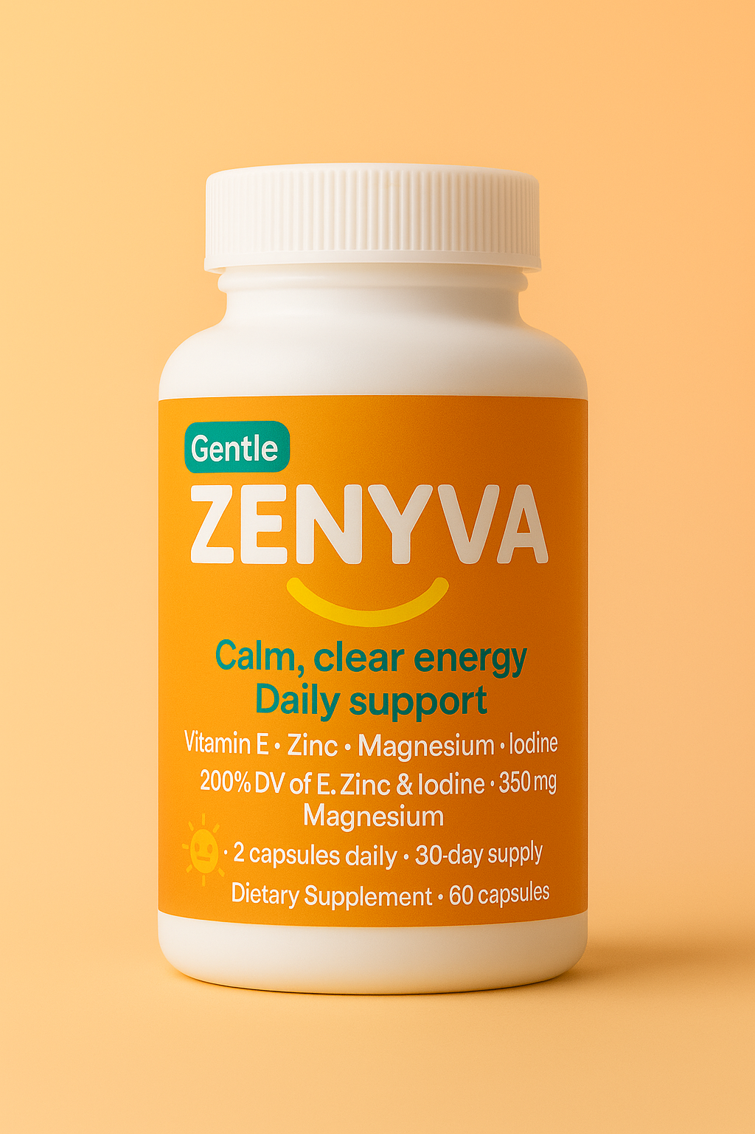
Do you have a specific color scheme in mind?
Any preferred font styles or sizes?
Design elements you would like to include (e.g., logo, symbols, images)?
Could you provide some references of designs or styles that you like? (links to websites are fine - they do not need to be supplement brands to be helpful to the designer).

4. Target Audience:

Who is your target customer for this supplement?
Any specific imagery or themes that resonate with your target audience?

5. Additional Notes: (Please provide as much detail as possible to ensure that we capture your vision accurately)

Please use your location for manufactured information

Front and Back labels above

Here is UPS code for label:
